**Power BI – Assignment I : Installing Power BI**

1. ***Final screenshot of Reports View Page :***

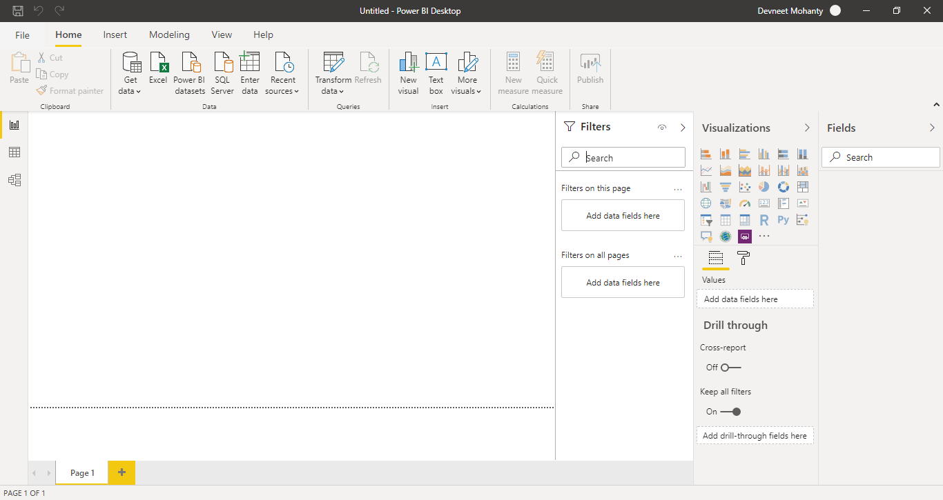

1. ***Report View :***

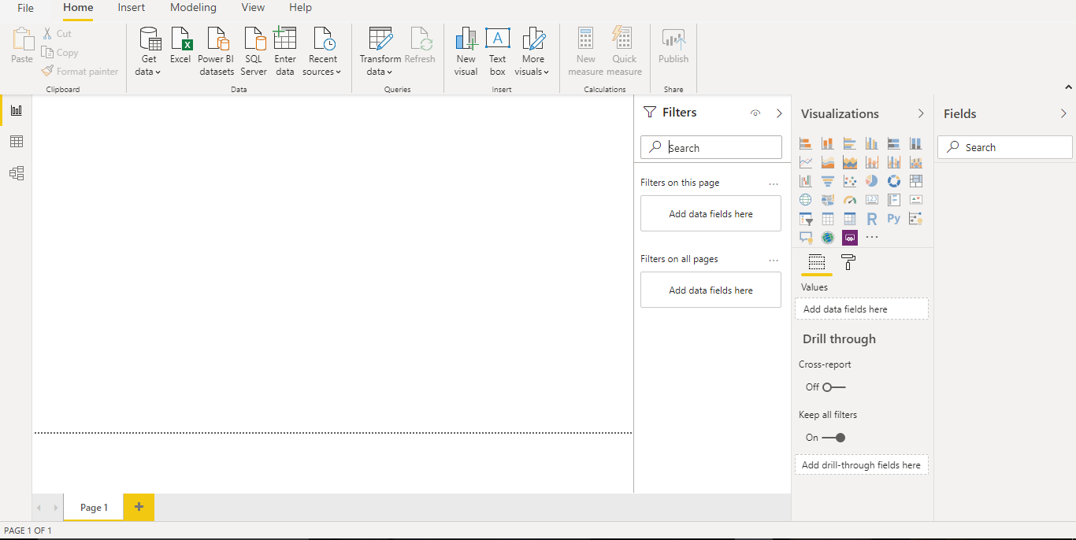

1. ***Data View :***

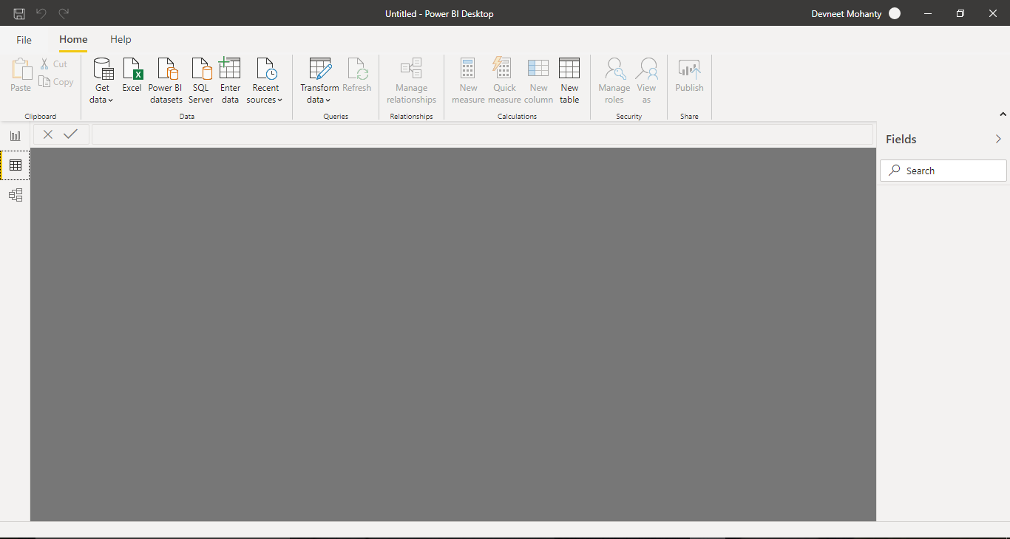

1. ***Model View :***

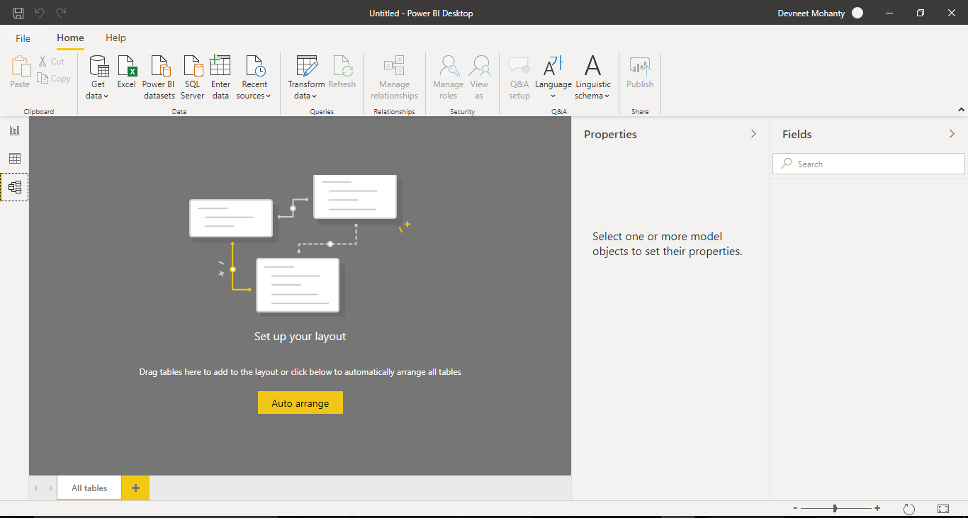

1. ***Power Query Editor :***

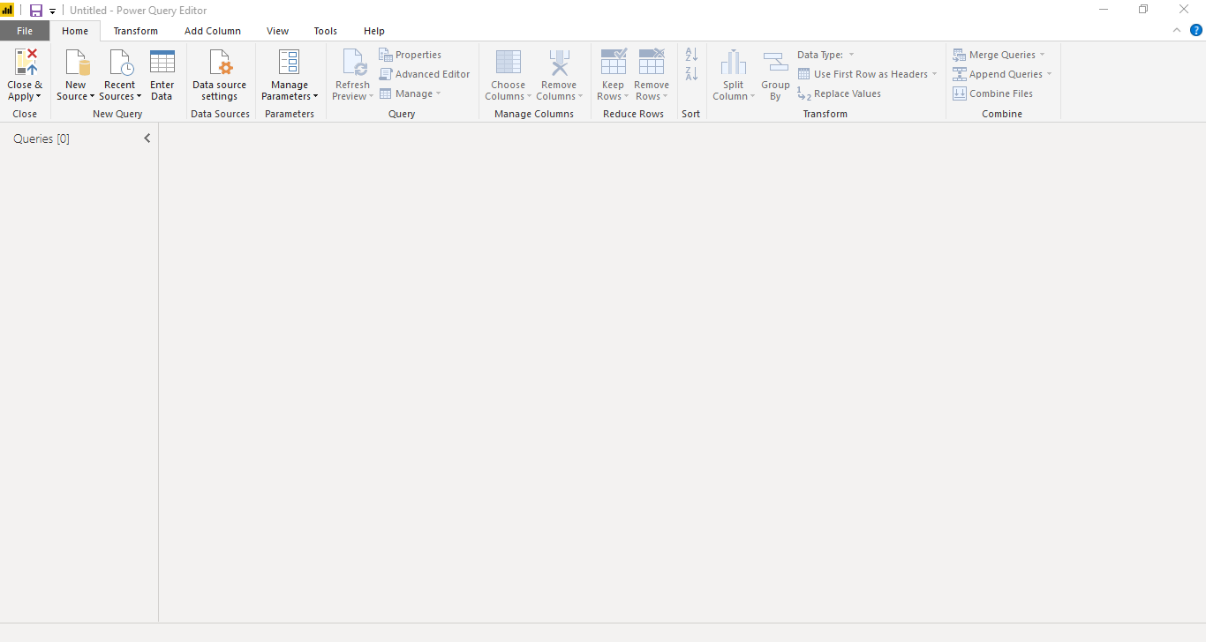

1. ***Advance Editor :***

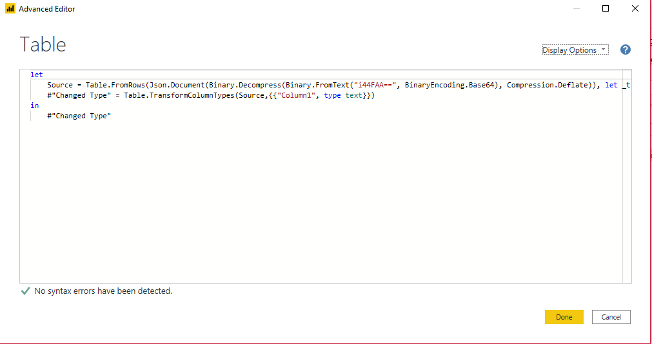

1. ***Pricing Options :***

|  |  |
| --- | --- |
| Products | Pricing |
| Power BI Desktop | **Free** |
| Power BI Pro | **$9.99 / Month** |
| Power BI Premium | **$4,995 / Month** |